Word template for the International Conference on Intelligent Systems and New Applications (ICISNA)

First Author1, Second Author2, Third Author3

1Department, University , Street, Country   
author1@.edu, ORCID: XXXX-XXXX-XXXX-XXXX

2Department, University , Street, Country   
author2@.edu, ORCID: XXXX-XXXX-XXXX-XXXX

3Department, University , Street, Country   
author3@.edu, ORCID: XXXX-XXXX-XXXX-XXXX

**Abstract**— This document presents the formatting instructions for the Proceedings of the International Conference on Intelligent Systems and New Applications (ICISNA). This document can serve as the base template for a Microsoft Word based typesetting system.

**Keywords**— Include at least 5 keywords or phrases

1. Introduction

This document represents a template for ICISNA. It can be downloaded from the conference website, and used as a reference in the typesetting of the final paper to be included in the conference proceedings. Extra information regarding the submission procedure is available at the conference website. Any question regarding the template or paper guidelines must be directed to info@atscience.org.

1. Page Layout

The conference page size is A4, which corresponds to a page of 210mm width and 297mm length (8.27'' x 11.69''). The margins must be:

* Top = 19mm (0.75")
* Bottom = 43mm (1.69")
* Left = Right = 14.32mm (0.56")

The space between columns is 4.2mm (0.165") which establishes the width of each column in 88.5mm (3.48'').

1. Page Style

All paragraphs must be indented 5.1mm (0.2''), and must be fully justified, that is both right and left justification at a time

The entire document must be in Times New Roman. To comply with IEEEXplore, Type 3 fonts must not be used. The recommended for size are summarized in Table I.

1. Title and Author Details

The title must use a font-size of 24pt and be centered in a single column. It must present each word capitalized, except for connecting words.

Author names must use a font size of 11pt; their affiliation and contact information should use 10pt. Author details must not show any professional title (e.g. Managing Director), any academic title (e.g. Dr.) or any membership of any professional organization (e.g. Senior Member IEEE).

To avoid confusion, the family name must be written as the last part of each author name (e.g John A.K. Smith).

TABLE I  
Font Sizes for Papers

|  |  |  |  |
| --- | --- | --- | --- |
| **Element** | **Font Size** | **Style** | **Associated Word Style** |
| Table caption | 8pt | Small Caps | *IEEE Table Caption* |
| Figure caption | 8pt | None | *IEEE Figure Caption* |
| Abstract Body | 9pt | Bold, Italic (Heading) | *IEEE Abstract* |
| Reference item | 10pt | Italic | *IEEE Reference Item* |
| Author Email address | 10pt | None | *IEEE Author Email* |
| Level-1 Heading | 10pt | Small Caps  Roman Numbering | *IEEE Heading 1* |
| Level-2 Heading | 10pt | Italic  Title style  Alphabetic numbering | *IEEE Heading 2* |
| Level-3 Heading | 10pt | Italic  Title style  Arabic numbering | *IEEE Heading 3* |
| Body Text | 10pt | None | *IEEE Paragraph* |
| Title | 24pt | Title style | *IEEE Title* |
| Author name | 11pt | None | *IEEE Author Name* |
| Affiliation | 10pt | Italic | *IEEE Author Affiliation* |

Each affiliation must include the name of the organization and the country where the author is based.

Contact information and email address are compulsory for the corresponding author

1. Section Headings

No more than 3 levels of headings should be used. All headings must be in 10pt fonts. As with the title, every wocrd in headings should be capitalized except for minor words.

1. Level-1 Heading: A level-1 heading should be in small caps, centered and numbered using uppercase Roman numerals. For an example see heading for Section I of this document. The only two level-1 headings which must not be numbered are “Acknowledgment” and “References”.
2. Level-2 Heading: A level-2 heading must be in Italic, left-justified and numbered using an uppercase alphabetic letter followed by a period. For example, see heading for Section II.A above.
3. Level-3 Heading: A level-3 heading must be indented, in Italic and numbered with an Arabic numeral followed by a right parenthesis. The level-3 heading must end with a colon. The body of the level-3 section immediately follows the level-3 heading in the same paragraph. This paragraph is an example of a level-3 heading.
4. Figures and Tables

Figures and tables must be centered in the column. Large figures and tables may span across both columns. Any table or figure that takes up more than 1 column width must be positioned either at the top or at the bottom of the page.

Graphics may be full color. All colors will be retained on the CDROM. Graphics must not use stipple fill patterns because they may not be reproduced properly. Please use only *SOLID FILL* colors which contrast well both on screen and on a black-and-white hardcopy, as shown in Fig. 1.



Fig. A sample line graph using colors which contrast well both on screen and on a black-and-white hardcopy

Fig. 2 shows an example of a low-resolution image which would not be acceptable, whereas Fig. 3 shows an example of an image with adequate resolution. Check that the resolution is adequate to reveal the important detail in the figure.

Please check all figures in your paper both on screen and on a black-and-white hardcopy. When you check your paper on a black-and-white hardcopy, please ensure that:

* the colors used in each figure contrast well,
* the image used in each figure is clear,
* all text labels in each figure are legible.

1. Figure Captions

Figures must be numbered using Arabic numerals. Figure captions must be in 8 pt Regular font. Captions of a single line (e.g. Fig. 2) must be centered whereas multi-line captions must be justified (e.g. Fig. 1). Captions with figure numbers must be placed after their associated figures, as shown in Fig. 1.

1. Table Captions

Tables must be numbered using uppercase Roman numerals. Table captions must be centred and in 8 pt Regular font with Small Caps. Every word in a table caption must be capitalized except for short minor words as listed in Section III-B. Captions with table numbers must be placed before their associated tables, as shown in Table I.

1. Page Numbers, Headers and Footers

Page numbers, headers and footers must not be used.



Fig. Example of an unacceptable low-resolution image

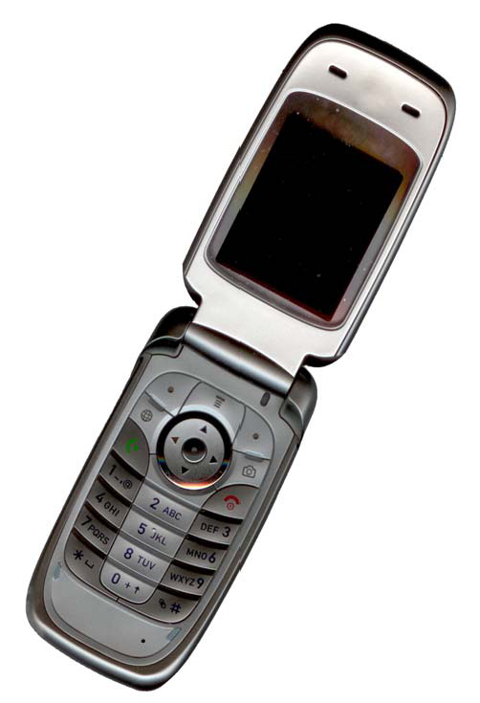

Fig. Example of an image with acceptable resolution

1. Links and Bookmarks

All hypertext links and section bookmarks will be removed from papers during the processing of papers for publication. If you need to refer to an Internet email address or URL in your paper, you must type out the address or URL fully in Regular font.

1. References

The heading of the References section must not be numbered. All reference items must be in 8 pt font. Please use Regular and Italic styles to distinguish different fields as shown in the References section. Number the reference items consecutively in square brackets (e.g. [1]).

When referring to a reference item, please simply use the reference number, as in [2]. Do not use “Ref. [3]” or “Reference [3]” except at the beginning of a sentence, e.g. “Reference [3] shows …”. Multiple references are each numbered with separate brackets (e.g. [2], [3], [4]–[6]).

Examples of reference items of different categories shown in the References section include:

* example of a book in [1]
* example of a book in a series in [2]
* example of a journal article in [3]
* example of a conference paper in [4]
* example of a patent in [5]
* example of a website in [6]
* example of a web page in [7]
* example of a databook as a manual in [8]
* example of a datasheet in [9]
* example of a master’s thesis in [10]
* example of a technical report in [11]
* example of a standard in [12]

1. PDF Generation

PDF generation for submission must ensure that the fonts are embedded into the final PDF, and only Type 1 fonts can be used. An Acrobat Distiller profile to automatically set most of the required options is available for download at: http://en.softonic.com/s/adobe-acrobat-distiller.

When using the built-in option of Microsoft Word 2007 to generate the final PDF version of the paper, the option *ISO 19005-1 compliant (PDF/A)* must be checked in order to embed the fonts.

1. Conclusions

The original version of this template was provided by courtesy of Causal Productions (www.causalproductions.com). Both Word and LaTeX versions are based in the IEEE available templates. The LaTeX templates depend on the official IEEEtran.cls and IEEEtran.bst files, whereas the Microsoft Word templates are self-contained.

Acknowledgment

The heading of the Acknowledgment section and the References section must not be numbered.

References

1. S. M. Metev and V. P. Veiko, *Laser Assisted Microtechnology*, 2nd ed., R. M. Osgood, Jr., Ed. Berlin, Germany: Springer-Verlag, 1998.
2. J. Breckling, Ed., *The Analysis of Directional Time Series: Applications to Wind Speed and Direction*, ser. Lecture Notes in Statistics. Berlin, Germany: Springer, 1989, vol. 61.
3. S. Zhang, C. Zhu, J. K. O. Sin, and P. K. T. Mok, “A novel ultrathin elevated channel low-temperature poly-Si TFT,” *IEEE Electron Device Lett.*, vol. 20, pp. 569–571, Nov. 1999.
4. M. Wegmuller, J. P. von der Weid, P. Oberson, and N. Gisin, “High resolution fiber distributed measurements with coherent OFDR,” in *Proc. ECOC’00*, 2000, paper 11.3.4, p. 109.
5. R. E. Sorace, V. S. Reinhardt, and S. A. Vaughn, “High-speed digital-to-RF converter,” U.S. Patent 5 668 842, Sept. 16, 1997.
6. (2002) The IEEE website. [Online]. Available: http://www.ieee.org/
7. M. Shell. (2002) IEEEtran homepage on CTAN. [Online]. Available: http://www.ctan.org/tex-archive/macros/latex/contrib/supported/IEEEtran/
8. *FLEXChip Signal Processor (MC68175/D)*, Motorola, 1996.
9. “PDCA12-70 data sheet,” Opto Speed SA, Mezzovico, Switzerland.
10. A. Karnik, “Performance of TCP congestion control with rate feedback: TCP/ABR and rate adaptive TCP/IP,” M. Eng. thesis, Indian Institute of Science, Bangalore, India, Jan. 1999.
11. J. Padhye, V. Firoiu, and D. Towsley, “A stochastic model of TCP Reno congestion avoidance and control,” Univ. of Massachusetts, Amherst, MA, CMPSCI Tech. Rep. 99-02, 1999.
12. *Wireless LAN Medium Access Control (MAC) and Physical Layer (PHY) Specification*, IEEE Std. 802.11, 1997.